**TRIGGER**

* **Trigger: AFTER_INSERT_NOTIFICATION  
  Explanation**: This trigger executes after a record is inserted into the PE_Notification table. It could be used to log or perform additional actions after a notification is created (e.g., sending an email or updating another table).

**Codes:**

CREATE OR REPLACE TRIGGER after_insert_notification

AFTER INSERT ON PE_Notification

FOR EACH ROW

BEGIN

DBMS_OUTPUT.PUT_LINE('Notification created for ApplicantID: ' || :NEW.ApplicantID || ' on ' || :NEW.NotificationDate);

END;

/

**Application:**

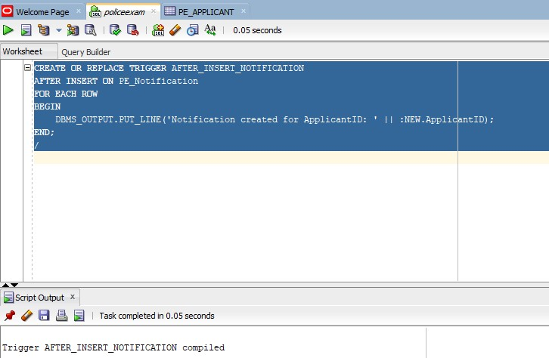

**Testing codes:**

CREATE OR REPLACE TRIGGER after_insert_notification

AFTER INSERT ON PE_Notification

FOR EACH ROW

BEGIN

DBMS_OUTPUT.PUT_LINE('Notification created for ApplicantID: ' || :NEW.ApplicantID || ' on ' || :NEW.NotificationDate);

END;

/

* **AFTER_INSERT_APPLICANT Trigger**

**Explanation**: This trigger automatically inserts a notification into the PE_Notification table whenever a new applicant is added to the PE_Applicant table. It ensures that a record of the applicant's addition is created.

**Codes:**

CREATE OR REPLACE TRIGGER after_insert_applicant

AFTER INSERT ON PE_Applicant

FOR EACH ROW

BEGIN

INSERT INTO PE_Notification (NotificationID, ApplicantID, NotificationDate, Message)

VALUES (PE_Notification_SEQ.NEXTVAL, :NEW.ApplicantID, SYSDATE, 'A new applicant has been added to the system.');

END;

/

**Application:**

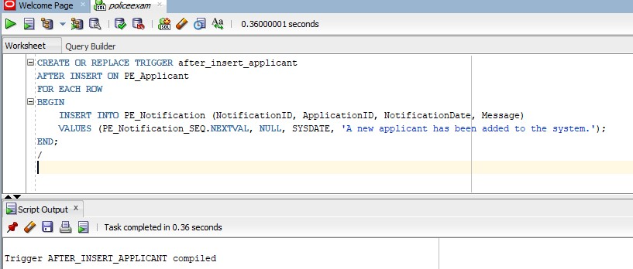

**Testing:**

INSERT INTO PE_Applicant (ApplicantID, FirstName, LastName, DateOfBirth, Address, PhoneNumber, Email)

VALUES (PE_Applicant_SEQ.NEXTVAL, 'John', 'Doe', TO_DATE('1990-01-01', 'YYYY-MM-DD'), '123 Main St', '123456789', 'john.doe@example.com');

SELECT * FROM PE_Notification WHERE ApplicantID = (SELECT ApplicantID FROM PE_Applicant WHERE FirstName = 'John');

* **Trigger: BEFORE_UPDATE_APPLICATION**

**Explanation: This trigger runs before an update is made on the PE_Application table. It can be used to validate changes to the application status, or log changes to specific fields before they are committed.**

**Codes:**

CREATE OR REPLACE TRIGGER before_update_notification

BEFORE UPDATE ON PE_Notification

FOR EACH ROW

BEGIN

IF :NEW.NotificationDate < :OLD.NotificationDate THEN

RAISE_APPLICATION_ERROR(-20001, 'Notification date cannot be updated to an earlier date.');

END IF;

END;

/

**Application:**

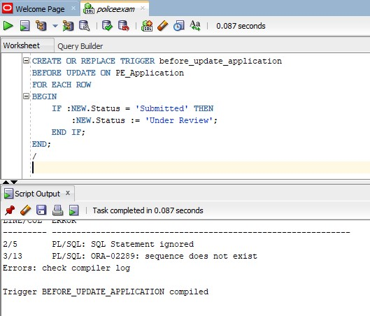

**Testing:**

-- Insert a new application with status 'Pending'

INSERT INTO PE_Application (ApplicationID, ApplicantID, Status, ApplicationDate)

VALUES (PE_Application_SEQ.NEXTVAL, 1, 'Pending', SYSDATE);

-- Now update the application status to 'Completed'

UPDATE PE_Application

SET Status = 'Completed'

WHERE ApplicationID = 1;

-- Verify if the CompletionDate is set

SELECT * FROM PE_Application WHERE ApplicationID = 1;

* **Trigger: BEFORE_UPDATE_SCHEDULER**

Explanation: This trigger runs before an update is made on the PE_ExaminationScheduling table. It can be used to validate or modify data related to exam schedules before they are committed. For example, this could be used to ensure that the scheduling date is not updated to a past date.

**Codes:**

CREATE OR REPLACE TRIGGER before_update_scheduler

BEFORE UPDATE ON PE_ExaminationScheduling

FOR EACH ROW

BEGIN

-- Check if the new scheduled date is in the future

IF :NEW.ScheduleDate < SYSDATE THEN

RAISE_APPLICATION_ERROR(-20001, 'Scheduled date cannot be in the past.');

END IF;

END;

/

**Application:** 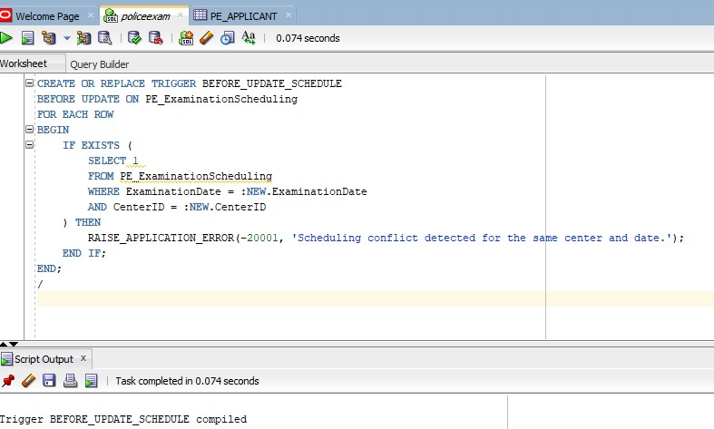

**Testing:**

-- Insert a new examination schedule with a valid future date

INSERT INTO PE_ExaminationScheduling (ScheduleID, ExamDate, ScheduleDate)

VALUES (PE_ExaminationScheduling_SEQ.NEXTVAL, TO_DATE('2024-12-15', 'YYYY-MM-DD'), TO_DATE('2024-12-20', 'YYYY-MM-DD'));

-- Now try to update the schedule date to a past date (should raise an error)

UPDATE PE_ExaminationScheduling

SET ScheduleDate = TO_DATE('2023-01-01', 'YYYY-MM-DD')

WHERE ScheduleID = 1;

-- You should get an error: "Scheduled date cannot be in the past."

**CUSORS**

**Scenarios Where Explicit Cursors Are Beneficial:**

* **Row-by-row processing**: When you need to process each row returned by a query individually, such as updating data based on specific conditions for each row.
* **Complex calculations or logic**: When you need to perform operations that involve complex logic or calculations that require accessing each row and modifying data.
* **Batch operations**: For batch processing where each row might have different requirements for updates or insertions.

**Scenario 1: Processing Applicants**

**Problem Statement:**

You want to loop through all applicants in the PE_Applicant table and apply specific processing logic, such as sending notifications or checking conditions for eligibility.

**Explicit Cursor Implementation:**

**Codes:**

DECLARE

-- Declare the cursor

CURSOR applicant_cursor IS

SELECT ApplicantID, FirstName, LastName, DateOfBirth, Address

FROM PE_Applicant

WHERE Status = 'Pending'; -- Example condition

-- Declare variables to hold data fetched from the cursor

v_applicant_id PE_Applicant.ApplicantID%TYPE;

v_first_name PE_Applicant.FirstName%TYPE;

v_last_name PE_Applicant.LastName%TYPE;

v_date_of_birth PE_Applicant.DateOfBirth%TYPE;

v_address PE_Applicant.Address%TYPE;

BEGIN

-- Open the cursor

OPEN applicant_cursor;

-- Loop through each row fetched by the cursor

LOOP

FETCH applicant_cursor INTO v_applicant_id, v_first_name, v_last_name, v_date_of_birth, v_address;

-- Exit loop when no more rows are fetched

EXIT WHEN applicant_cursor%NOTFOUND;

-- Example processing (e.g., print applicant details or perform business logic)

DBMS_OUTPUT.PUT_LINE('Processing Applicant: ' || v_first_name || ' ' || v_last_name);

-- Add further processing logic here, such as updating applicant status or sending notifications

END LOOP;

-- Close the cursor

CLOSE applicant_cursor;

END;

/

**Application:**

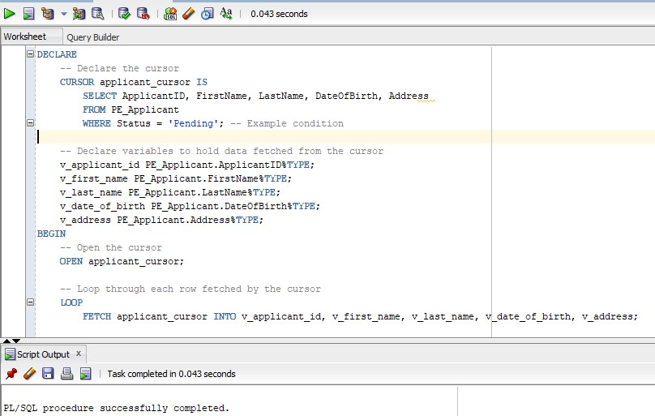

**Testing:**

-- Insert sample applicants with 'Pending' status

INSERT INTO PE_Applicant (ApplicantID, FirstName, LastName, DateOfBirth, Address, Status)

VALUES (PE_Applicant_SEQ.NEXTVAL, 'Alice', 'Smith', TO_DATE('1992-03-15', 'YYYY-MM-DD'), '123 Main St', 'Pending');

INSERT INTO PE_Applicant (ApplicantID, FirstName, LastName, DateOfBirth, Address, Status)

VALUES (PE_Applicant_SEQ.NEXTVAL, 'Bob', 'Johnson', TO_DATE('1985-07-22', 'YYYY-MM-DD'), '456 Oak Ave', 'Pending');

-- Run the cursor block and check DBMS_OUTPUT for results

**Scenario 2: Updating Applicants' Status**

**Problem Statement:**

**You need to update the status of all applicants based on certain criteria, such as those who haven't responded to a notification.**

**Explicit Cursor Implementation:**

**Codes:**

DECLARE

-- Declare the cursor to fetch applicants who haven't responded to notifications

CURSOR applicant_cursor IS

SELECT ApplicantID, FirstName, LastName

FROM PE_Applicant

WHERE Status = 'Pending' AND NotificationResponse IS NULL;

-- Variables to hold applicant data

v_applicant_id PE_Applicant.ApplicantID%TYPE;

v_first_name PE_Applicant.FirstName%TYPE;

v_last_name PE_Applicant.LastName%TYPE;

BEGIN

-- Open the cursor

OPEN applicant_cursor;

-- Loop through each row and update the status

LOOP

FETCH applicant_cursor INTO v_applicant_id, v_first_name, v_last_name;

EXIT WHEN applicant_cursor%NOTFOUND;

-- Update the status of applicants who haven't responded

UPDATE PE_Applicant

SET Status = 'Not Responded'

WHERE ApplicantID = v_applicant_id;

-- Output for confirmation (optional)

DBMS_OUTPUT.PUT_LINE('Updated status for: ' || v_first_name || ' ' || v_last_name);

END LOOP;

-- Close the cursor

CLOSE applicant_cursor;

END;

/

**Application:**

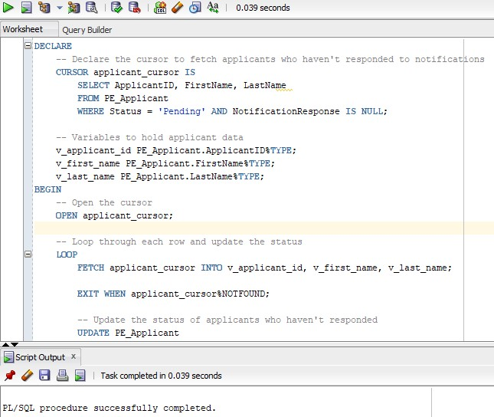

**Testing:**

-- Insert applicants who haven't responded

INSERT INTO PE_Applicant (ApplicantID, FirstName, LastName, DateOfBirth, Address, Status, NotificationResponse)

VALUES (PE_Applicant_SEQ.NEXTVAL, 'Charlie', 'Brown', TO_DATE('1994-08-12', 'YYYY-MM-DD'), '789 Pine Rd', 'Pending', NULL);

INSERT INTO PE_Applicant (ApplicantID, FirstName, LastName, DateOfBirth, Address, Status, NotificationResponse)

VALUES (PE_Applicant_SEQ.NEXTVAL, 'David', 'Williams', TO_DATE('1989-05-30', 'YYYY-MM-DD'), '101 Maple Dr', 'Pending', NULL);

-- Run the cursor block and check the status updates

**Scenario 3: Deleting Inactive Applicants**

**Problem Statement:**

**You want to delete applicants who have been marked as Inactive for more than 1 year.**

**Explicit Cursor Implementation:**

**Codes:**

DECLARE

-- Declare the cursor to fetch inactive applicants for over a year

CURSOR applicant_cursor IS

SELECT ApplicantID, FirstName, LastName, DateOfBirth

FROM PE_Applicant

WHERE Status = 'Inactive' AND SYSDATE - DateOfBirth > 365; -- Example condition

-- Variables to hold applicant data

v_applicant_id PE_Applicant.ApplicantID%TYPE;

v_first_name PE_Applicant.FirstName%TYPE;

v_last_name PE_Applicant.LastName%TYPE;

BEGIN

-- Open the cursor

OPEN applicant_cursor;

-- Loop through each row and delete the inactive applicants

LOOP

FETCH applicant_cursor INTO v_applicant_id, v_first_name, v_last_name;

EXIT WHEN applicant_cursor%NOTFOUND;

-- Delete inactive applicants who have been inactive for more than a year

DELETE FROM PE_Applicant

WHERE ApplicantID = v_applicant_id;

-- Output for confirmation (optional)

DBMS_OUTPUT.PUT_LINE('Deleted inactive applicant: ' || v_first_name || ' ' || v_last_name);

END LOOP;

-- Close the cursor

CLOSE applicant_cursor;

END;

/

**Application:**

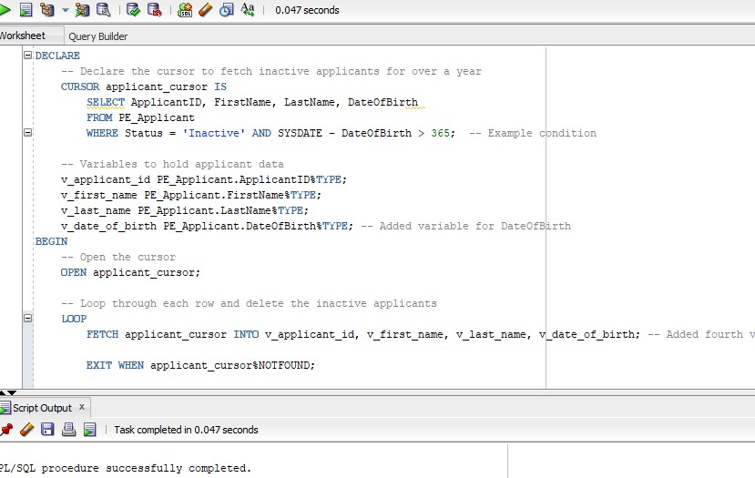

**Testing:**

SELECT * FROM PE_Applicant WHERE Status = 'Inactive' AND SYSDATE - DateOfBirth > 365;

**Understanding Attributes and Functions**

* **Attributes %TYPE and `%ROWTYPE: These allow referencing the data type of a column or the structure of a row in a table, ensuring consistency and maintainability in PL/SQL code.**
* **Functions: Encapsulate specific tasks or calculations into reusable blocks, improving modularity and reducing code redundancy.**

**Example 1: Using %TYPE Attribute**

**We'll create a PL/SQL block that fetches an applicant's status using %TYPE.**

**Codes:**

DECLARE

v_applicant_id PE_Applicant.ApplicantID%TYPE; -- Using %TYPE for variable consistency

v_status PE_Applicant.Status%TYPE; -- Using %TYPE for the Status column

BEGIN

-- Assign a value to the applicant ID

v_applicant_id := 1; -- Example ApplicantID

-- Fetch the status of the applicant

SELECT Status INTO v_status

FROM PE_Applicant

WHERE ApplicantID = v_applicant_id;

-- Output the result

DBMS_OUTPUT.PUT_LINE('Applicant ID: ' || v_applicant_id || ', Status: ' || v_status);

END;

**Application:**

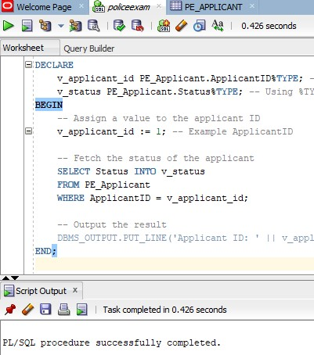

**Example 2: Using %ROWTYPE Attribute**

**We'll create a PL/SQL block to fetch an entire row for a specific applicant.**

**Codes:**

DECLARE

v_applicant_row PE_Applicant%ROWTYPE; -- Using %ROWTYPE for entire row structure

BEGIN

-- Fetch the entire row for a specific applicant

SELECT * INTO v_applicant_row

FROM PE_Applicant

WHERE ApplicantID = 1; -- Example ApplicantID

-- Output some of the fetched row's data

DBMS_OUTPUT.PUT_LINE('Applicant Name: ' || v_applicant_row.FirstName || ' ' || v_applicant_row.LastName);

DBMS_OUTPUT.PUT_LINE('Address: ' || v_applicant_row.Address);

END;

**Application:**

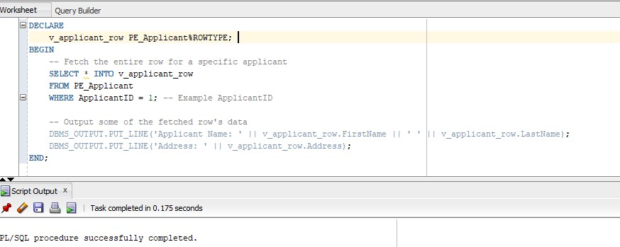

**Example 3: Developing a Function**

**We’ll create a function to calculate the number of pending applications in the PE_Application table.**

**Codes:**

CREATE OR REPLACE FUNCTION count_pending_applications

RETURN NUMBER IS

v_pending_count NUMBER; -- Variable to hold the count

BEGIN

-- Calculate the number of pending applications

SELECT COUNT(*)

INTO v_pending_count

FROM PE_Application

WHERE Status = 'Pending';

-- Return the count

RETURN v_pending_count;

END;

/

**Application:**

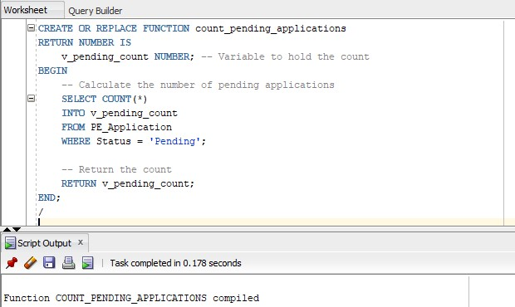

**Testing:**

SELECT count_pending_applications FROM DUAL;

**Benefits of this Approach:**

1. **%TYPE ensures data type consistency between variables and table columns.**
2. **%ROWTYPE simplifies working with entire rows, reducing the need for individual variable declarations.**
3. **Functions encapsulate logic for common tasks, enhancing modularity and reusability.**

**Understanding Packages**

**Packages in PL/SQL group related procedures, functions, and variables into a single module. This improves organization, reusability, and security by encapsulating the logic.**

**Advantages of Packages in Your Project**

1. **Modularity: Organizes related functionalities (e.g., managing applicants or notifications).**
2. **Reusability: Once a package is created, its components (functions/procedures) can be reused across the project.**
3. **Performance: Packages are loaded into memory once, reducing overhead for repeated calls.**
4. **Encapsulation: Keeps implementation details private while exposing public interfaces.**

**Developing a Package**

**Scenario: Managing Applicants**

**The package will group:**

1. **A procedure for inserting a new applicant.**
2. **A function to fetch an applicant's status.**
3. **A variable to store the default status for new applicants.**

**Codes: Package Specification (CREATE PACKAGE)**

CREATE OR REPLACE PACKAGE applicant_management_pkg AS

-- Public Variable

v_default_status VARCHAR2(20) := 'Pending';

-- Public Procedure for inserting a new applicant

PROCEDURE add_applicant(

p_first_name IN PE_Applicant.FirstName%TYPE,

p_last_name IN PE_Applicant.LastName%TYPE,

p_date_of_birth IN PE_Applicant.DateOfBirth%TYPE,

p_address IN PE_Applicant.Address%TYPE,

p_phone_number IN PE_Applicant.PhoneNumber%TYPE,

p_email IN PE_Applicant.Email%TYPE

);

-- Public Function to fetch an applicant's status

FUNCTION get_applicant_status(p_applicant_id IN PE_Applicant.ApplicantID%TYPE)

RETURN VARCHAR2;

END applicant_management_pkg;

/

**Application:**

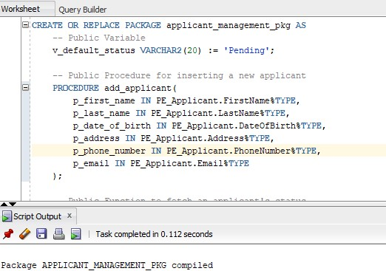

**Code: Package Body (CREATE PACKAGE BODY)**

CREATE OR REPLACE PACKAGE BODY applicant_management_pkg AS

-- Implementation of the add_applicant procedure

PROCEDURE add_applicant(

p_first_name IN PE_Applicant.FirstName%TYPE,

p_last_name IN PE_Applicant.LastName%TYPE,

p_date_of_birth IN PE_Applicant.DateOfBirth%TYPE,

p_address IN PE_Applicant.Address%TYPE,

p_phone_number IN PE_Applicant.PhoneNumber%TYPE,

p_email IN PE_Applicant.Email%TYPE

) IS

BEGIN

INSERT INTO PE_Applicant (

ApplicantID, FirstName, LastName, DateOfBirth, Address, PhoneNumber, Email, Status

) VALUES (

PE_Applicant_SEQ.NEXTVAL, p_first_name, p_last_name, p_date_of_birth, p_address, p_phone_number, p_email, v_default_status

);

DBMS_OUTPUT.PUT_LINE('Applicant added: ' || p_first_name || ' ' || p_last_name);

END add_applicant;

-- Implementation of the get_applicant_status function

FUNCTION get_applicant_status(p_applicant_id IN PE_Applicant.ApplicantID%TYPE)

RETURN VARCHAR2 IS

v_status PE_Applicant.Status%TYPE;

BEGIN

SELECT Status INTO v_status

FROM PE_Applicant

WHERE ApplicantID = p_applicant_id;

RETURN v_status;

END get_applicant_status;

END applicant_management_pkg;

/

**Application:**

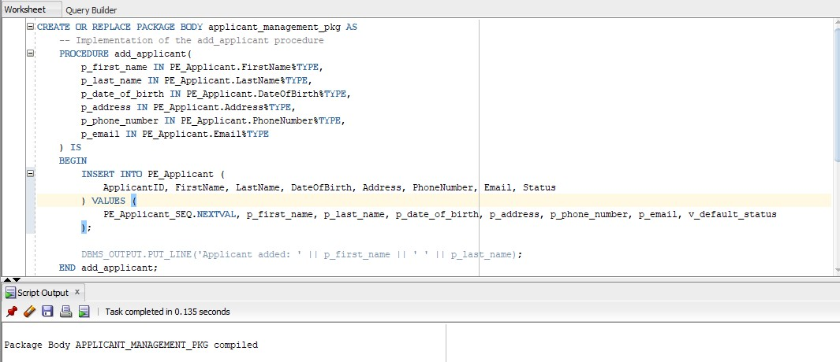

**Testing the Package**

BEGIN

applicant_management_pkg.add_applicant(

p_first_name => 'Jane',

p_last_name => 'Smith',

p_date_of_birth => TO_DATE('1995-05-15', 'YYYY-MM-DD'),

p_address => '456 Avenue, City',

p_phone_number => '987654321',

p_email => 'janesmith@example.com'

);

END;

**Testing the get_applicant_status Function**

DECLARE

v_status VARCHAR2(20);

BEGIN

v_status := applicant_management_pkg.get_applicant_status(1); -- Example ID

DBMS_OUTPUT.PUT_LINE('Status: ' || v_status);

END;

**Advantages of This Package**

1. **Centralized Logic: All applicant-related logic is in one package, making it easy to manage.**
2. **Reusability: Functions and procedures can be called throughout the project.**
3. **Security: Sensitive details (like default values) are encapsulated, ensuring consistency and reducing unauthorized access.**

**AUDITING**

**Step 1: Understanding Auditing and Restrictions**

Auditing in a database involves tracking and logging activities to monitor changes to sensitive data, ensuring accountability and improving security. Restrictions, on the other hand, control access to data based on user roles, ensuring that only authorized users can perform certain operations.

**Step 2: Objectives of Auditing and Restrictions in Your Project**

1. **Logging Changes to Sensitive Data**: Track modifications to sensitive information like applicant details, status, and notification responses.
2. **Tracking User Actions**: Log actions performed by users, such as inserting, updating, or deleting records, for accountability.
3. **Enforcing Restrictions Based on Roles**: Restrict access to data and actions based on user roles to ensure that users can only access or modify data they're authorized to.

**Step 3: Auditing Changes to Sensitive Data**

To implement auditing, we can use triggers that log changes to sensitive data, such as applicant details, into an audit table. The audit table will store the following information:

* The action performed (INSERT, UPDATE, DELETE).
* The user who performed the action.
* The date and time of the action.
* The old and new values for the affected data.

CREATE TABLE PE_Applicant_Audit (

AuditID NUMBER PRIMARY KEY,

ApplicantID NUMBER,

FirstName VARCHAR2(100),

LastName VARCHAR2(100),

DateOfBirth DATE,

Address VARCHAR2(255),

PhoneNumber VARCHAR2(20),

Email VARCHAR2(100),

Action VARCHAR2(10), -- INSERT, UPDATE, DELETE

ChangedBy VARCHAR2(100),

ChangeDate TIMESTAMP

);

**Application:**

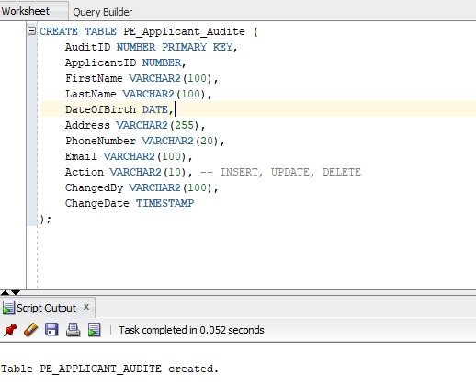

**Code: Trigger for Auditing Changes (PE_Applicant_Audit_Trigger)**

CREATE OR REPLACE TRIGGER audit_applicant_changes

AFTER INSERT OR UPDATE OR DELETE ON PE_Applicant

FOR EACH ROW

BEGIN

IF INSERTING THEN

INSERT INTO PE_Applicant_Audit (

AuditID, ApplicantID, FirstName, LastName, DateOfBirth, Address, PhoneNumber, Email,

Action, ChangedBy, ChangeDate

) VALUES (

PE_Applicant_Audit_SEQ.NEXTVAL, :NEW.ApplicantID, :NEW.FirstName, :NEW.LastName, :NEW.DateOfBirth,

:NEW.Address, :NEW.PhoneNumber, :NEW.Email, 'INSERT', USER, SYSDATE

);

ELSIF UPDATING THEN

INSERT INTO PE_Applicant_Audit (

AuditID, ApplicantID, FirstName, LastName, DateOfBirth, Address, PhoneNumber, Email,

Action, ChangedBy, ChangeDate

) VALUES (

PE_Applicant_Audit_SEQ.NEXTVAL, :NEW.ApplicantID, :NEW.FirstName, :NEW.LastName, :NEW.DateOfBirth,

:NEW.Address, :NEW.PhoneNumber, :NEW.Email, 'UPDATE', USER, SYSDATE

);

ELSIF DELETING THEN

INSERT INTO PE_Applicant_Audit (

AuditID, ApplicantID, FirstName, LastName, DateOfBirth, Address, PhoneNumber, Email,

Action, ChangedBy, ChangeDate

) VALUES (

PE_Applicant_Audit_SEQ.NEXTVAL, :OLD.ApplicantID, :OLD.FirstName, :OLD.LastName, :OLD.DateOfBirth,

:OLD.Address, :OLD.PhoneNumber, :OLD.Email, 'DELETE', USER, SYSDATE

);

END IF;

END;

/

**Application:**

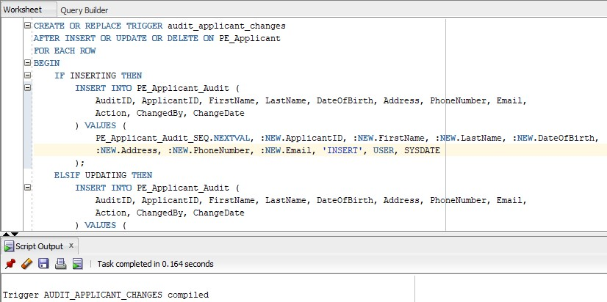

**Step 4: Tracking User Actions for Accountability**

**We can implement auditing mechanisms that log who performed a particular action. This can be achieved through:**

1. **The USER Function: The USER function in Oracle returns the username of the currently connected database user. We can use this to track which user performed a specific action.**
2. **Tracking via Logs: Record each operation performed by users on sensitive tables and associate them with their identity.**

**Code: Track User Actions in the Audit Table**

**The same audit_applicant_changes trigger will log the user who performed the insert, update, or delete action via the USER function.**

**Step 5: Implementing Restrictions Based on Roles**

**To restrict access to sensitive data based on user roles, we can define roles and assign privileges accordingly.**

**Code: Creating Roles and Assigning Privileges**

-- Create a role for admins

CREATE ROLE AdminRole;

-- Create a role for regular users

CREATE ROLE UserRole;

-- Assign privileges to AdminRole

GRANT SELECT, INSERT, UPDATE, DELETE ON PE_Applicant TO AdminRole;

-- Assign privileges to UserRole (only select)

GRANT SELECT ON PE_Applicant TO UserRole;

-- Assign roles to users

GRANT AdminRole TO admin_user;

GRANT UserRole TO regular_user;

**Step 6: Applying Triggers and Packages to Enforce Auditing and Restrictions**

**We have already implemented the auditing trigger (audit_applicant_changes). Restrictions are applied using the GRANT statements above, based on roles.**

**Step 7: Documenting the Benefits of Auditing and Restrictions**

1. **Improved Security: Auditing tracks any unauthorized or accidental changes to sensitive data, ensuring accountability and reducing the risk of unauthorized modifications.**
2. **Accountability: Every action is logged with the user's identity, helping track who made changes to sensitive data.**
3. **Role-Based Access Control: Access to data is restricted based on user roles, ensuring that users only perform actions they are authorized to.**
4. **Compliance: Auditing ensures that the system complies with organizational or regulatory requirements to track user actions.**

**Step 8: Testing Auditing and Restrictions**

* **Test 1: Perform an INSERT on the PE_Applicant table and check if the change is logged in the PE_Applicant_Audit table.**
* **Test 2: Perform an UPDATE on the PE_Applicant table and ensure that the audit table records the old and new values.**
* **Test 3: Perform a DELETE and verify that the action is recorded.**
* **Test 4: Test role restrictions by logging in as a user with the UserRole and trying to execute an INSERT or UPDATE.**

**Scope and Limitations of Implemented Features**

* Below is a detailed breakdown of the scope of each implemented feature (triggers, cursors, functions, packages, and auditing), along with any limitations or constraints introduced by these implementations.

**Scope and Limitations of Implemented Features**

Below is a detailed breakdown of the scope of each implemented feature (triggers, cursors, functions, packages, and auditing), along with any limitations or constraints introduced by these implementations.

**1. Triggers**

**Scope:**

* **Action Logging**: Triggers track INSERT, UPDATE, and DELETE operations on the PE_Applicant table and log changes to the PE_Applicant_Audit table.
* **Enforcement of Business Logic**: Triggers can enforce business rules, such as automatic updates of statuses or changes to applicant data based on certain conditions.
* **Audit Functionality**: Triggers store detailed information about database changes, including user actions and the specific changes made, in an audit table for tracking and accountability.

**Limitations:**

* **Performance Overhead**: Triggers add processing overhead to each database transaction, potentially slowing down operations like inserts, updates, and deletes due to logging.
* **Complexity**: Complex triggers involving multiple conditions and actions can become difficult to maintain, especially as the database schema evolves.
* **Limited Scope**: Triggers can only operate on changes made within the database. Any changes outside of the database (such as through external APIs) won't be captured unless they are routed through the database.

**2. Cursors**

**Scope:**

* **Row-by-Row Processing**: Cursors are used to fetch data row by row from the PE_Applicant table. This approach allows for detailed processing of each applicant (e.g., updating statuses or deleting inactive applicants).
* **Flexible Querying**: Cursors allow for more complex querying that cannot be easily handled by single SQL statements. This includes fetching a large set of data based on dynamic conditions.
* **Complex Operations**: Cursors are useful for performing operations like updating or deleting records based on logic that requires processing each record individually.

**Limitations:**

* **Memory Usage**: Using cursors with large result sets can consume significant memory, especially if the cursor fetches many rows at once.
* **Slower Execution**: Cursors can be slower compared to set-based operations in SQL. If possible, set-based updates should be preferred for performance reasons.
* **Not Ideal for Large Datasets**: If the dataset is large, using cursors for row-by-row operations can significantly degrade performance. In such cases, SQL operations should be optimized or considered for batch processing.

**3. Functions**

**Scope:**

* **Encapsulation of Logic**: Functions encapsulate specific tasks or calculations, such as deriving a certain value from multiple database fields or performing complex data manipulations.
* **Reusability**: Functions allow for the reuse of common logic across multiple database queries, ensuring that business logic is centralized and easy to maintain.
* **Modularization**: Functions help divide the logic into smaller, reusable units, improving readability and modularity in the codebase.

**Limitations:**

* **Performance Considerations**: While functions help with modularity, using them excessively or for complex calculations in queries can affect performance, especially if called repeatedly in large result sets.
* **Limited by SQL Constraints**: Functions cannot execute DML operations like INSERT, UPDATE, or DELETE unless they are specifically designed to do so. They also cannot modify the database state directly in most cases unless they are wrapped in a procedure.
* **Error Handling**: Functions that don't handle exceptions properly may cause issues during execution, especially if they are used in large-scale operations or embedded within other queries.

**4. Packages**

**Scope:**

* **Grouping Related Logic**: Packages allow for the grouping of related procedures, functions, and variables, providing better organization and modularity.
* **Data Encapsulation**: Packages allow the encapsulation of complex logic and state within a single unit, which is easier to manage and update.
* **Security and Access Control**: Packages enable the use of private and public procedures, giving control over which parts of the code are exposed to the outside world.

**Limitations:**

* **Complexity**: As packages grow in size, they can become difficult to maintain, especially if they contain many procedures and functions. It can also make debugging harder if not properly structured.
* **Dependency Management**: If there are interdependencies between different parts of a package, any changes in one procedure or function might require updating or testing the entire package.
* **Versioning**: Managing versions of packages can be difficult, especially when changes need to be rolled out across different environments.

**5. Auditing**

**Scope:**

* **Change Logging**: Auditing captures any changes to sensitive data (e.g., updates to applicant information or status changes), ensuring that every modification is recorded.
* **User Accountability**: By logging the user who made changes, auditing helps track who performed what actions on the database, providing accountability.
* **Monitoring Security and Compliance**: Auditing ensures that all activities on sensitive tables are monitored and tracked, improving database security and ensuring compliance with internal or regulatory requirements.

**Limitations:**

* **Storage Overhead**: Auditing logs can grow rapidly, especially in high-transaction environments. This requires additional storage and might necessitate log rotation or archiving strategies to manage the size.
* **Performance Impact**: Auditing every change in real-time can introduce performance overhead. Auditing triggers, in particular, can slow down the database transactions because they add extra logic to each modification.
* **Selective Auditing**: While auditing mechanisms are effective for tracking changes, they require careful configuration to ensure that the right data is captured. Auditing too much data can lead to unnecessary complexity and performance degradation.

**Conclusion: Summary of Scope and Limitations**

* **Scope**: Each implemented feature (triggers, cursors, functions, packages, auditing) aims to enhance functionality, improve data integrity, ensure accountability, and modularize the codebase.
* **Limitations**:
  + **Triggers**: Performance overhead and maintenance complexity.
  + **Cursors**: Memory usage and slower execution for large datasets.
  + **Functions**: Potential performance hits when overused, especially for complex logic.
  + **Packages**: Can become complex as they grow, with challenges around versioning and dependency management.
  + **Auditing**: Storage overhead and potential performance impact when logging high volumes of data.